ADVERTISEMENT
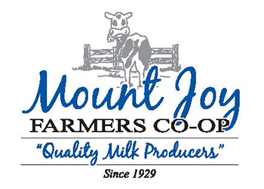
Mount Joy Farmers Co-Op Association, based in Mount Joy, PA, is a farmer-owned cooperative representing more than 250 local dairy producers. Since 1929, the Co-Op has remained dedicated to supporting its members and ensuring safe, reliable, and continuous milk production. The Co-Op has also maintained a strong and collaborative relationship with Dairy Farmers of America (DFA), who play a key role in the marketing and processing of their milk. Built on honesty, integrity, and long-standing relationships, the cooperative partners closely with multi-generational farm families across the region. Mount Joy Farmers Co-Op upholds high standards for quality milk hauling while staying competitive within the dairy industry. Their enduring commitment to service, community, and partnership reflects the cooperative values at the heart of their mission.
Mount Joy Farmers Co-Op Association is seeking a dedicated and highly adaptable General Manager to lead day-to-day operations and serve as the primary point of communication for office staff, drivers, and farm members. In this role, the General Manager will oversee all cooperative functions, ensuring seamless coordination with farmers, our logistics team, and milk processors. This position is hands-on and cross-trained, often stepping in where needed to maintain uninterrupted service for farm members. The ideal candidate will embody the Co-Op’s values of honesty, integrity, strong relationships, and operational excellence while supporting a lean business model that maximizes member value. This General Manager role offers the opportunity to make a meaningful impact by strengthening farmer partnerships, ensuring reliable milk transport, and guiding a respected, long-standing cooperative committed to serving its producers.
General Manager position qualifications:
- A background in agriculture is strongly preferred; experience with dairy operations or the transportation industry is strongly preferred
- Minimum of 3 years of leadership and/or management experience; required
- Experience working in farmer‑facing roles, cooperatives, or other relationship‑driven environments; preferred
- Proficiency with technology, including Microsoft Office Suite; essential
- Excellent written and verbal communication skills; essential
- CDL license is a plus
- Demonstrated community involvement; strongly preferred
Please submit resume and cover letter: www.NorthGroupConsultants.com/jobs

