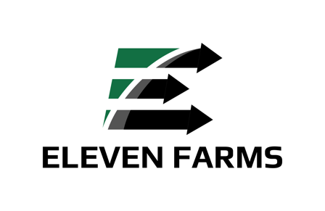
Job Title: Feed Operations Assistant (Part-Time)

Job Summary:
Join our innovative dairy farm operation as a Feed Operations Assistant at Eleven Farms, located in Elliottsburg, PA, nestled in scenic Perry County. We specialize in robotic dairy farming, utilizing cutting-edge technology to manage our herd of 120 Holstein dairy cows. This position offers the opportunity to play a crucial role in our farm's daily operations by efficiently managing feeding tasks and operating various farm machinery, including tractors, skid loaders, and feed mixers. If you're passionate about agriculture and enjoy working in a dynamic farm environment, we'd love to have you on our team!

Responsibilities:
- Operate tractors, skid loaders, and feed mixers to transport and distribute feed to livestock.
- Follow feeding schedules and protocols to ensure animals receive the appropriate nutrition.
- Monitor feed inventory levels and communicate with the farm manager to coordinate feed orders.
- Perform routine maintenance and inspections on feeding equipment to ensure proper functioning.
- Maintain cleanliness and organization in feed storage areas and equipment sheds.
- Assist with other farm tasks as needed, including scraping animal housing areas.
- Follow safety protocols and procedures to prevent accidents and ensure the well-being of both humans and animals on the farm.
- Collaborate with other team members to complete daily tasks and achieve farm goals.

Qualifications:
- Previous experience operating tractors, skid loaders, or other equipment is required.
- Knowledge of feeding practices and livestock nutrition is preferred but not required.
- Ability to work independently and prioritize tasks in a fast-paced environment.
- Strong mechanical aptitude is preferred.
- Physical stamina, the ability to lift 50 lbs, and perform tasks in various weather conditions.
- Excellent communication skills and a positive attitude towards working as part of a team.
- Valid driver's license and reliable transportation to and from the farm.

Benefits:
- Part-time position with 10-20 hours per week. The work schedule will have fixed days and times each week. Employees have the flexibility to choose their preferred days, provided that once chosen, those days remain consistent.
- Opportunity to gain experience with modern farming equipment and practices.
- Access to a supportive team environment.

How to Apply:
Please submit a resume outlining your interest in the position and any relevant skills or experience to LeeAnn McLaughlin at LeeAnnMcLaughlin.EF@gmail.com. Please put ‘Feed Operations Assistant’ in the subject line.

